**Phase-3 Lesson End Project -1**

**Source code:**

First open the test plan give name to the test plan to lesson end project

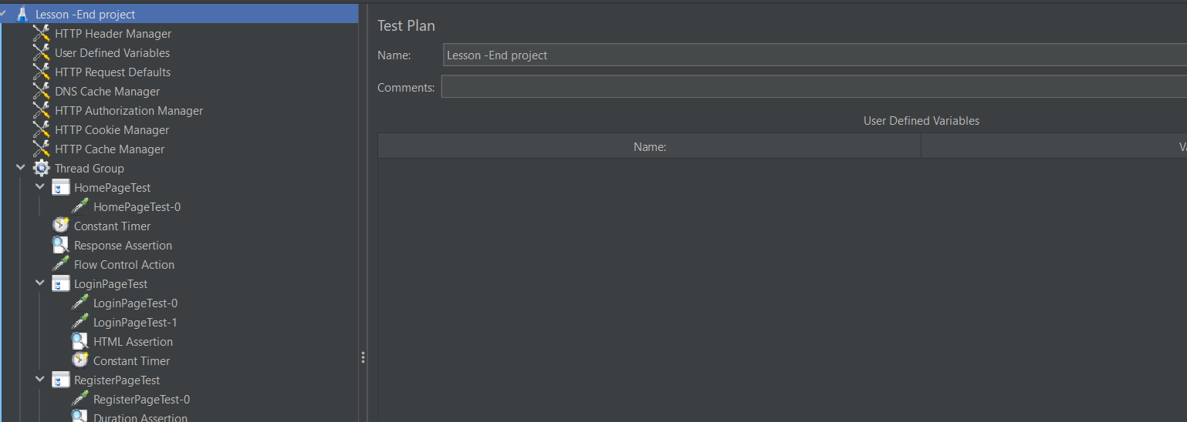

Next add some HTTP Headers

Next step add thread group to test plan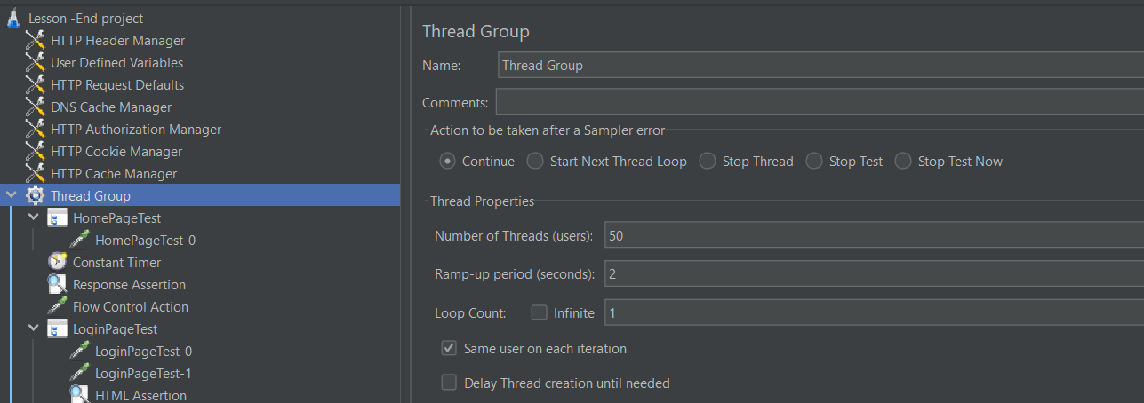

In Thread group add some logic controller and give name as home page test

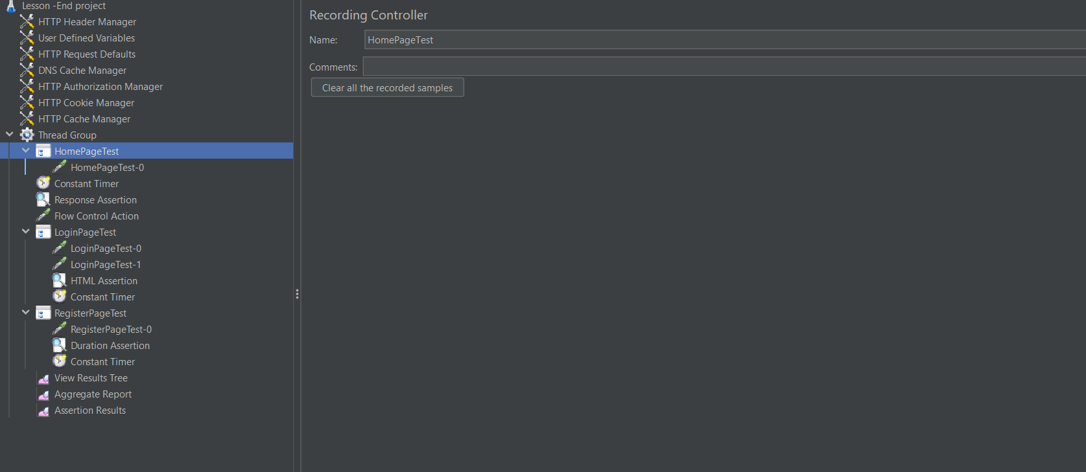

Next step add Http request go to thread group>add >samplers>http request give name as homepage test -0

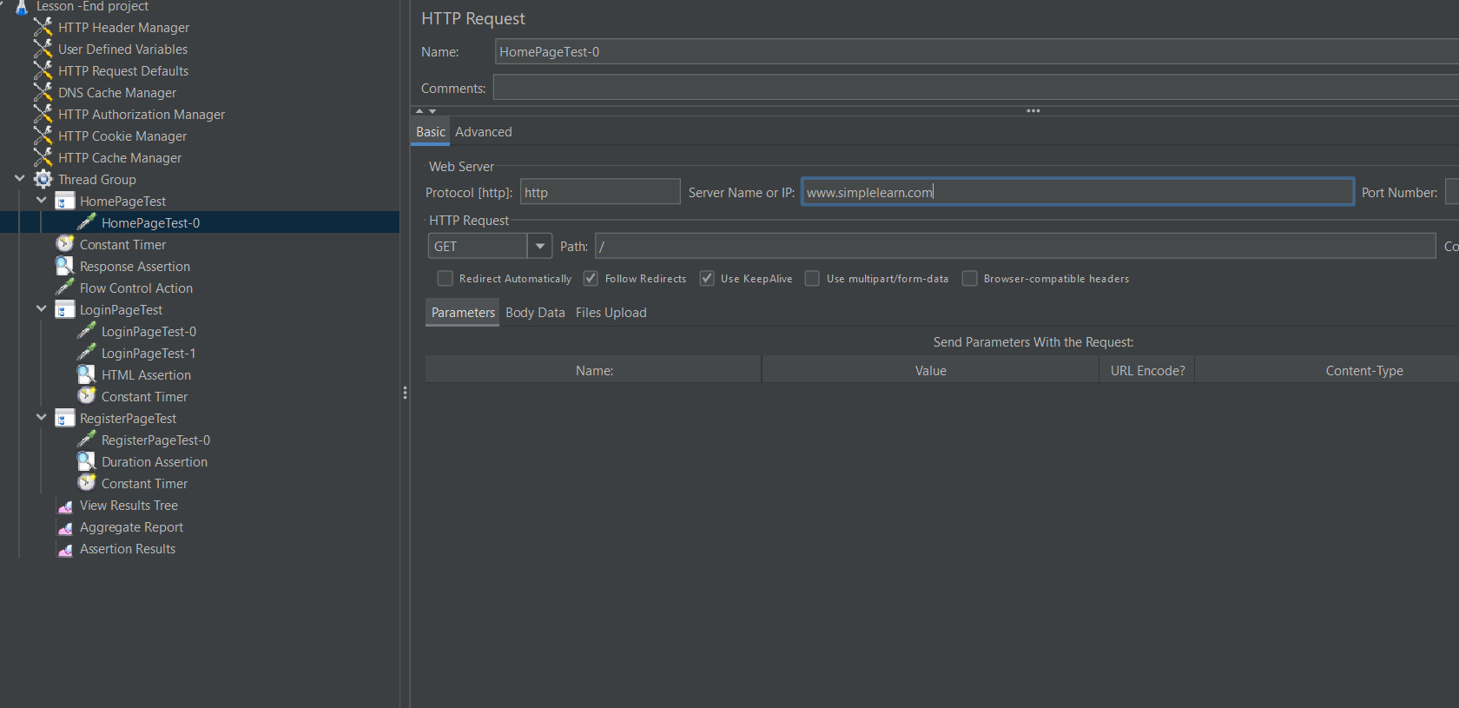

Next step add timers in constant timer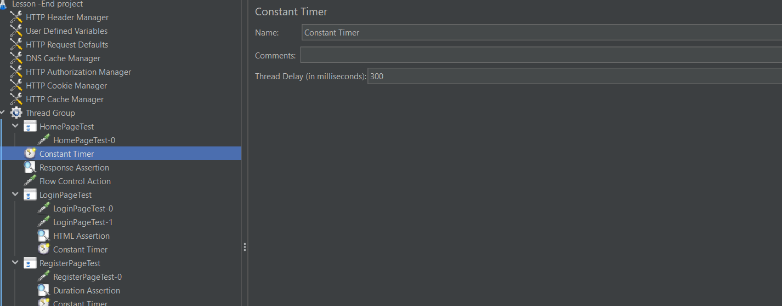

Next add Assertions use Response assertion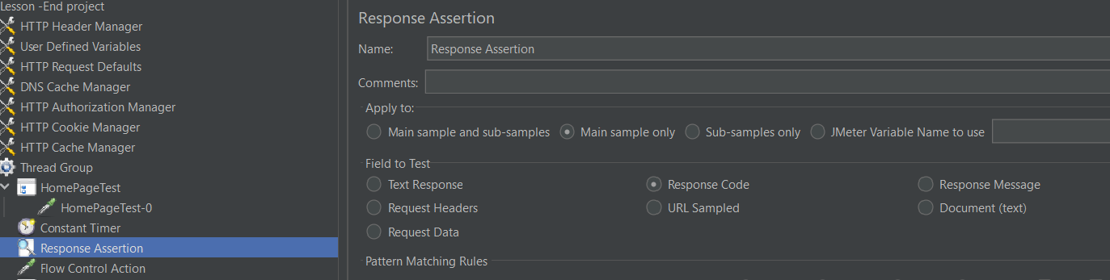

Next step add flow control Action

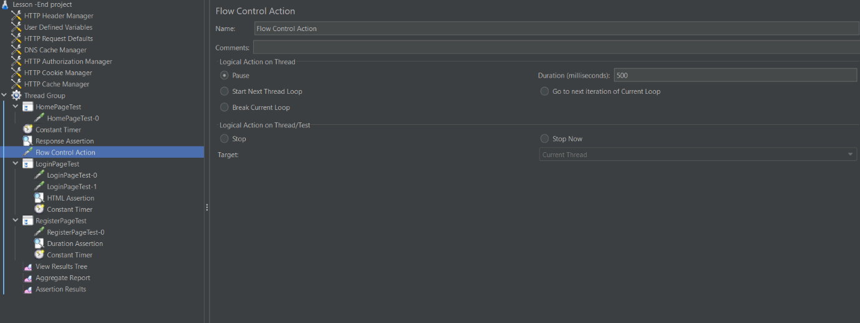

Next give controller right click>thread group>go to logical controller>give controller name name as loginPage test

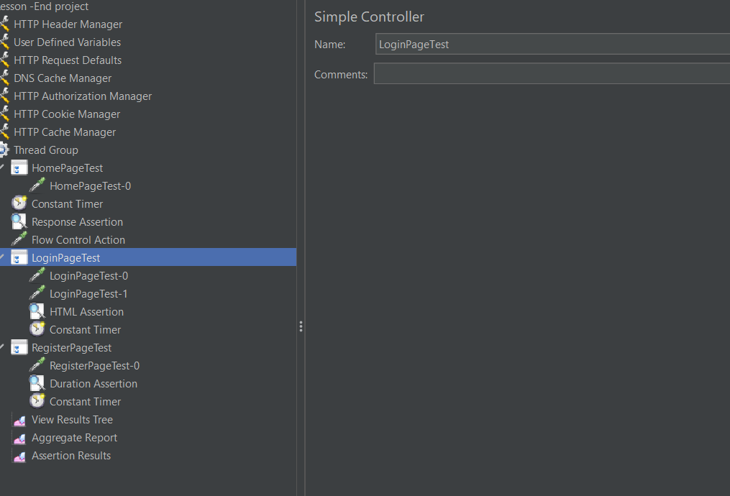

Add html request name as loginPagetest-0

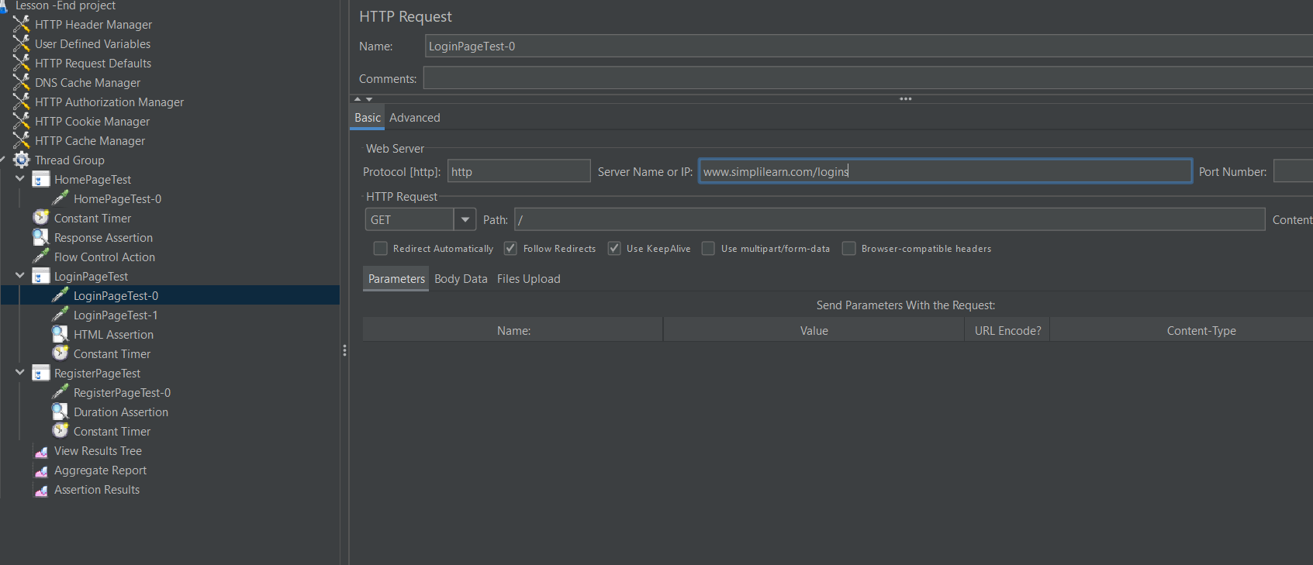

Next add html request to give name as login page test-1

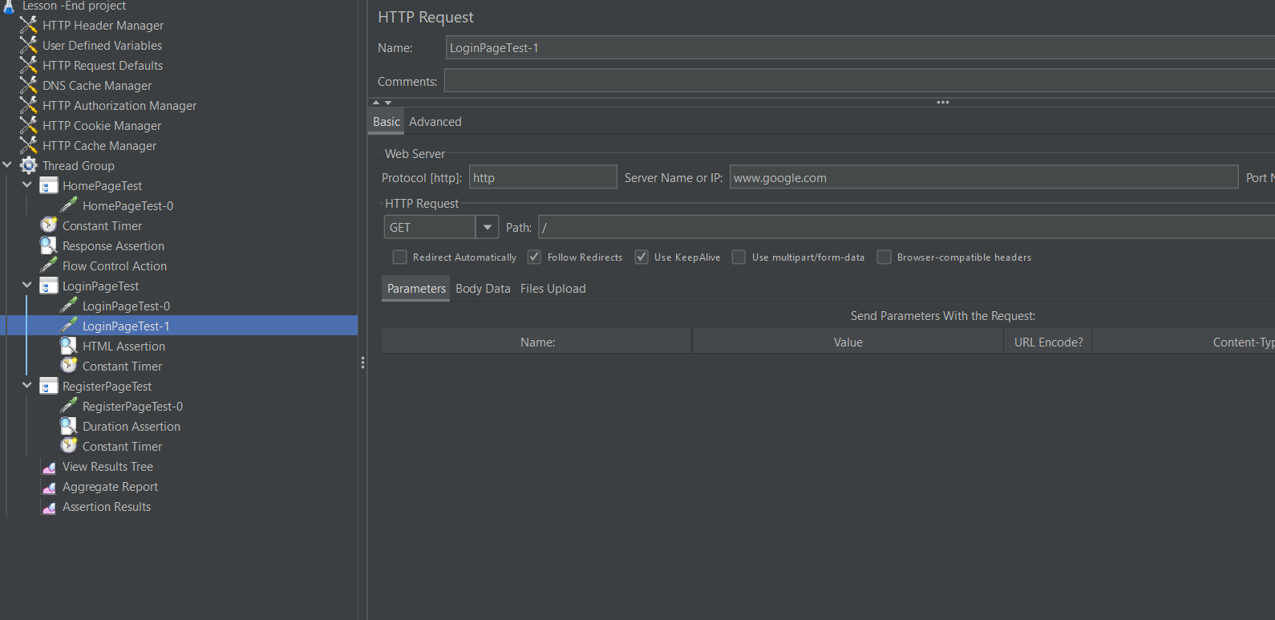

Next add HTML assertion go to samplers>assertions>html assertion

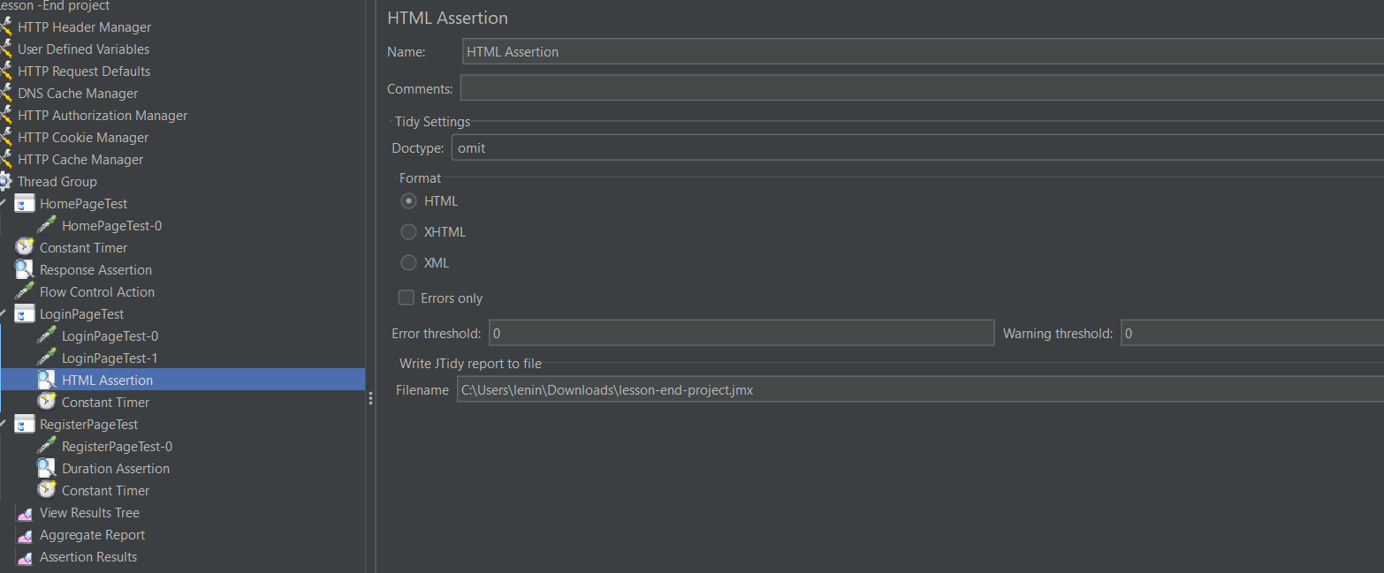

Next add timers go to samplers section>timers>constant timers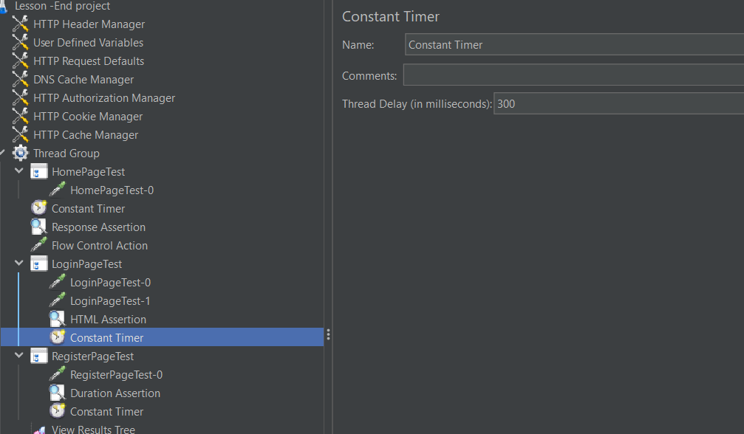

Next step add go to thread group> add > logical controller>throughput controller>give name as RegisterPage test

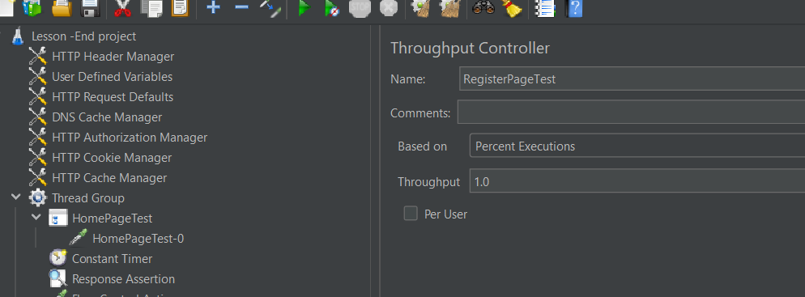

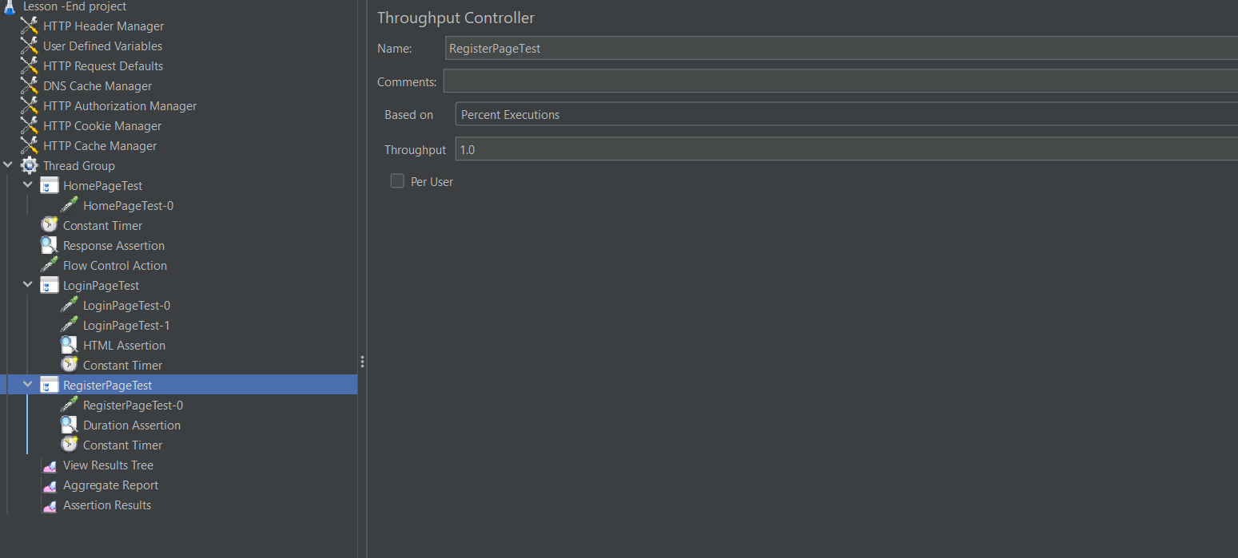

Next add http request name as RegisterdPage test-0

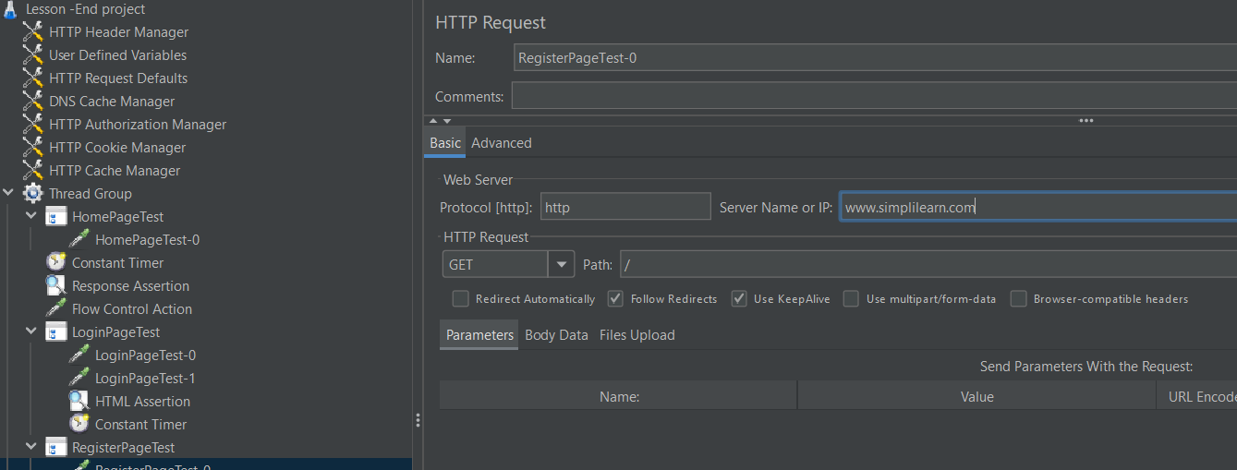

Next add Assertion assertion name duration assertion

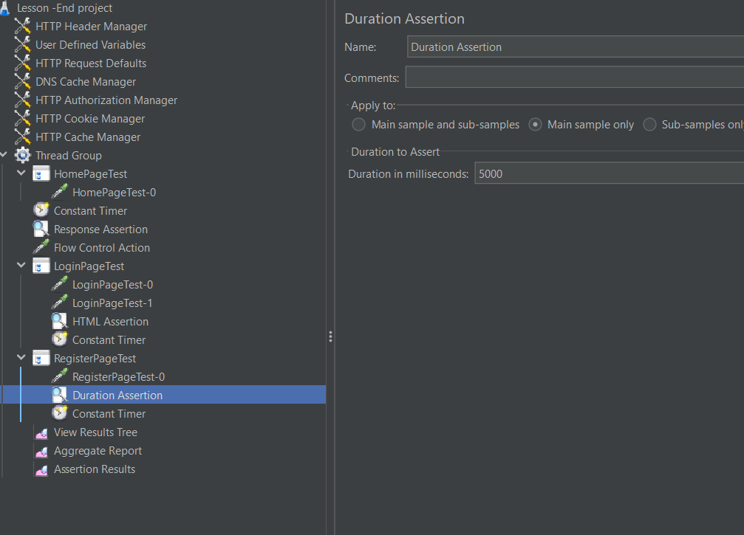

Next add timer select constant timer

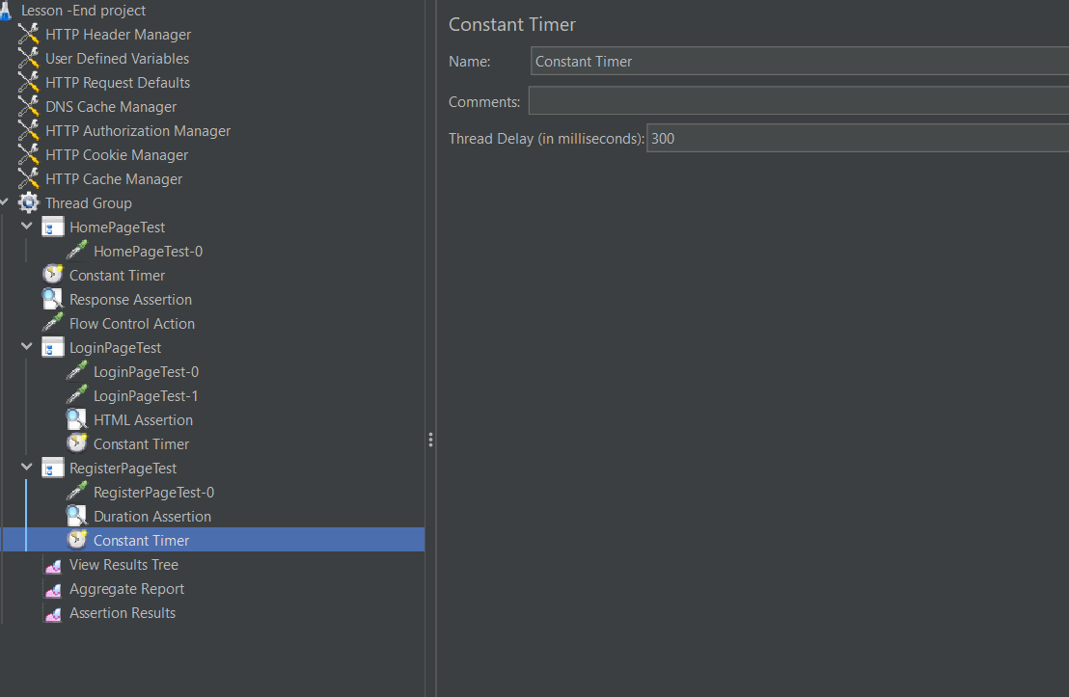

Next go to test plan >add > listeners>select view results tree

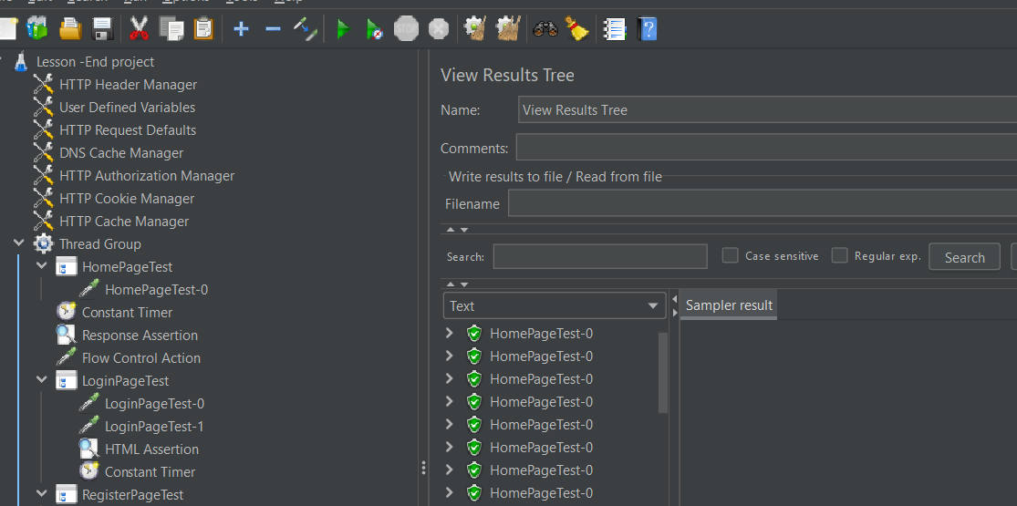

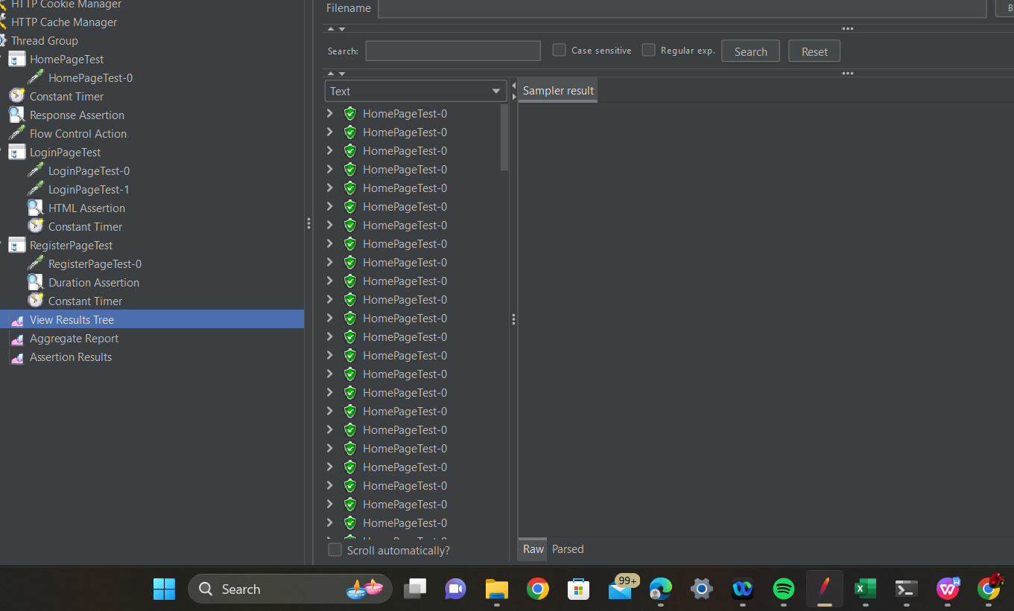

Next add aggregation report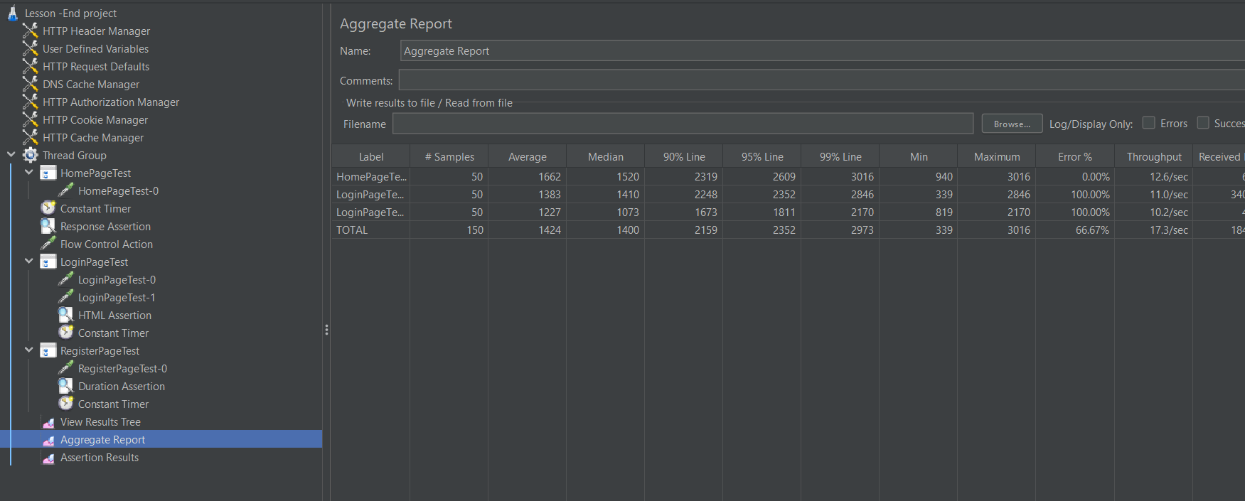

Next add test plan >thread group> listeners>assertion results

